**Google Vision API and Imagion**

**By Roiana Reid** December 10, 2017at 7:15pm ET

We needed a systematic way to determine key features of the images in our dataset. We decided on the Google Vision API, a reputable service that was convenient, as we used the Google Compute Engine for out project. Extracting features of images added a very interesting dimension to our analysis, allowing us to determine the features that were most closely associated with high, medium and low scoring images. Two features of the Google Vision API were applied to the ~12k images: label detector and color detector.

The label detector in the Google Vision API uses machine learning models to classify images into different classes. For each image, we used the API to detect the class that had the highest associated probability. Our analysis yielded 896 unique classes, but we only used classes that were associated with at least 50 images for analysis. We then determined the classes most frequently linked to each of the image scores in the [0,10] range. The results were quite interesting with some classes clearly frequently associated with only higher-ranked images and others with lower-ranked images. For example “girl” and “mammal” were both frequently associated with the highest rated images (Scores: 9, 10) and “product” and “meal” tended to be frequently associated with lower rated images.

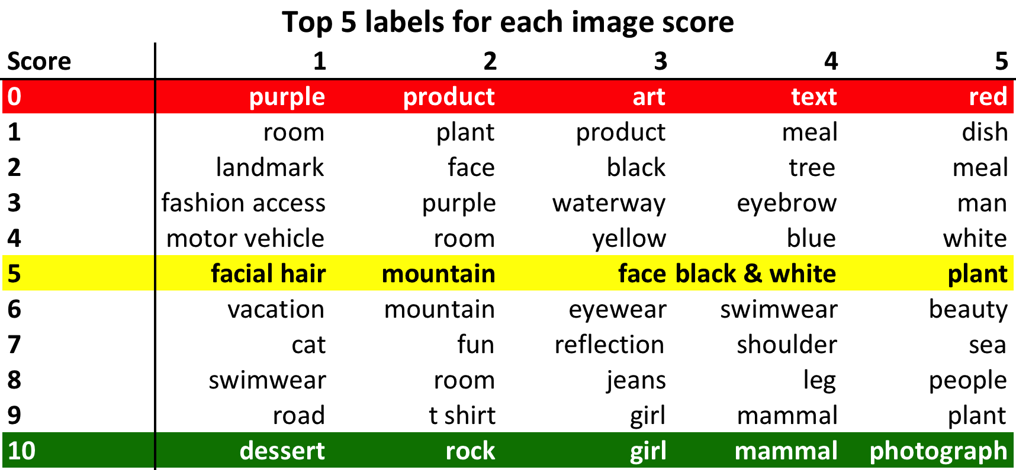

The color detector in the Google Vision API extracts the dominant colors associated with images. Similar to our analysis with the label detector we only used the dominant color that was assigned the highest probability. We determined the average RGB (red, green, blue) decimal codes across the image scores (in the [0,10] range). There was not a major difference in RGB decimal codes across scores, but it seems that darker shades of colors (red, green, blue) tend to be associated with higher quality images. For example, the red decimal code averaged 139 for low-scoring images (score: 0) and averaged 132 for high-scoring images (score: 10).

We incorporated the label detector results of the Google Vision API analysis into our application by making recommendations to users on how to improve the quality of images. These suggestions are included in the score rating analysis that is displayed to the user after images are uploaded. Further work will involve making these suggestions more individualized and tailored to each user.

